[1]

AutoRCX

Anas Derkaoui, and Youness Taleb

***Abstract*—AutoRCX is essentially a robot that is capable of traveling great distances and while also being able not only to detect obstacles, but also to dodge them. The car is programmed by an ARDUINO UNO card that gives it all the instructions, and down the road the card will be replaced by an NVIDIA JETSON NANO that has much more capabilities and is equipped with artificial intelligence.**

***Index Terms*—ARDUINO, NVIDIA JETSON NANO, Autonomous car, Artificial Intelligence**

I. INTRODUCTION

I

n the recent years, the field of autonomous vehicles has seen significant advancements, with companies like Tesla and Waymo leading the way in developing self-driving cars for consumer use [1]. Nonetheless, the technology behind autonomous vehicles is not limited to just cars; it can also be applied to remote-controlled (RC) vehicles. One such example is an autonomous RC car that is equipped with four ultrasonic sensors, one laser sensor, a servo motor, and a DC motor for propulsion, all controlled by an ARDUINO UNO R3 card. Our autonomous RC car is based on a 1/10 RC car frame and is equipped with a lot of components that enable it to travel long distances while being able to avoid collisions. The project of AutoRCX started in the month of October 2022, and it has come a long way. From being just a bear frame with no programmable parts to an almost capable autonomous RC car. This project, has recently achieved significant milestones. In this article, we highlight the latest advancements in the project, including the incorporation of a custom laser-cut frame, 3D-printed sensor mounts, and the integration of ROS on the Nvidia Jetson card. These enhancements have propelled the AutoRCX car to new heights, both in terms of functionality and design. The car is now about ready to wander around with minimal miscalculations of the distance separating it from obstacles. In this article, we will delve into the technology behind this autonomous RC car and explore its capabilities and potential applications.

II. Building Stage

The initial plan was to 3D print all car components, like this project [2], and use laser cutting to shape the frame from wood and plastic. However, we encountered difficulties in creating the steering mechanism through 3D printing, as it was both complex and time-consuming. As a result, we decided to purchase the car frame, which proved to be a more efficient solution. This project [3] suggested the same idea. Not only did it save us a significant amount of time, but it also provided a sturdy and complete frame that included the challenging parts that were difficult to 3D print. This autonomous RC car is designed to navigate its environment using a combination of ultrasonic and laser sensors. The ultrasonic sensors are used for measuring the distance to nearby objects, while the laser sensor is used for more precise measurements, this is why it was mounted on the front of the car. Furthermore, the car's servo motor is responsible for controlling the steering, allowing the car to navigate around obstacles. Lastly, the DC motor provides the necessary propulsion to move the car.

The ultrasonic sensors work by emitting a high-frequency sound and measuring the time it takes for the sound to bounce back. This information is used to calculate the distance to the object or potential obstacle. The laser sensor, on the other hand, uses a laser beam to measure the distance to an object, and is much more precise than the other type of sensors.

The car's servo motor is controlled by the ARDUINO UNO R3 card. It receives instructions from the sensors and uses this information to determine the necessary steering angle. The DC motor is controlled by a motor driver, allowing the car to move forward or backward at different speeds as needed.

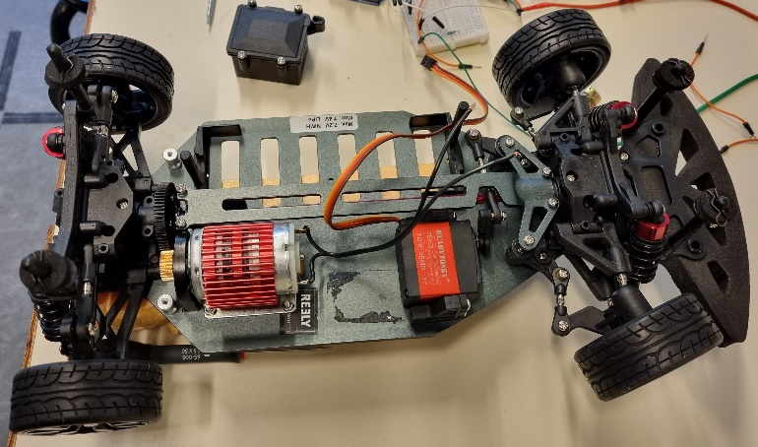

Fig. 1. The car frame with the DC motor, the servo motor and the car tires already mounted.

The motor has a mounting bracket that screws through the car frame to hold the motor as Fig. 1 shows. For that, we had to take some measurements in order for the motor’s gear to make a solid contact with gear of the car frame, then drill the holes. Unlike the DC motor, the servo motor had two L-shaped plastic mounting brackets screwed on the frame that held it in place. It is connected to the steering arm responsible of turning the tires.

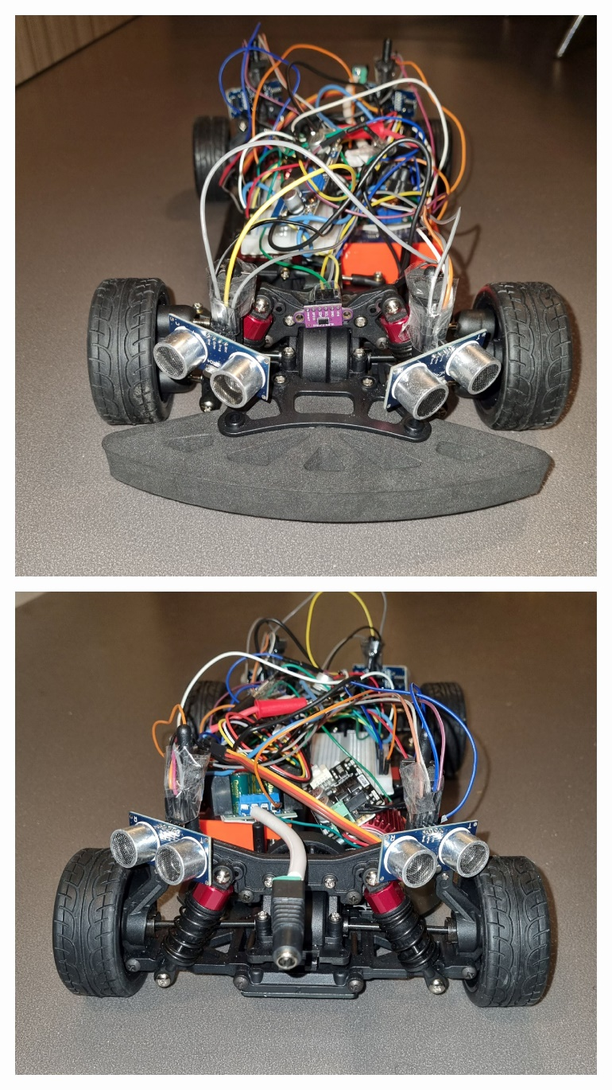

Fig. 2. This picture shows the front of the car. The 4 ultrasonic sensors (two at the front and two at the back) and the laser sensor are all wired up to the ARDUINO UNO CARD, and the car is ready to be tested.

One of the notable improvements made to the AutoRCX (Fig. 2) was the development of a sleek and sturdy frame. Utilizing the laser cutting technique, a frame made of plexiglass was crafted. This frame not only provides structural support but also securely houses the Arduino Uno card at the heart of the car's control system. The precision of laser cutting ensures a precise fit, allowing for easy access to the Arduino Uno and other components.

Also, in order to optimize the placement and stability of various sensors, custom mounts were designed and 3D printed, replacing the previous method of duct taping the sensors to the frame. These mounts ensure a secure and reliable attachment, preventing unwanted movement during the car's autonomous operations. With the new sensor mounts, the sensors are accurately positioned to maximize their efficiency and effectiveness.

Lastly, apart from functional improvements, the AutoRCX car has also undergone enhancements in terms of its design. The custom laser-cut frame and 3D-printed sensor mounts contribute to a more streamlined and professional appearance. Attention was given to wiring, durability, and ease of maintenance, resulting in a visually appealing and practical design.

III. Coding Stage

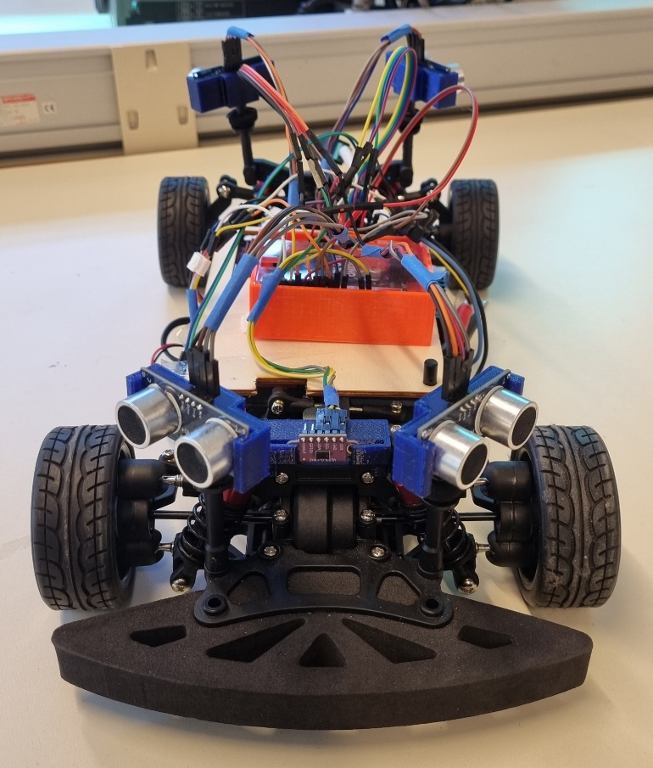Fig. 3. This picture shows the front of the car after undergoing some aesthetical improvements.

The car, shown in Fig. 3, is now equipped with all the components that will enable it to drive autonomously, although the code is the only remaining part of the project that will need a lot of modifications and tweaks so as to make the RC car fully capable of driving independently. Speaking of which, the code is programmed by ARDUINO as stated lately, and is present on my GitHub link [4]. As of now, we are working effortfully to get the NVIDIA JETSON NANO card to work, then use the capabilities of artificial intelligence that it offers to control the car.

The use of artificial intelligence (AI) in autonomous cars is crucial for their proper functioning. AI algorithms are used to interpret sensor data and make decisions based on that data. This includes tasks such as object detection, lane keeping, and decision making. This information is then used to make decisions about the car’s speed and direction of travel. One such project is the use of artificial intelligence (AI) and NVIDIA technology in autonomous cars, and in our case, the NVIDIA JETSON NANO.

One of the key components of this project is the use of Google Colab, a platform that allows for the easy creation and sharing of Jupyter notebooks. This allows for the development and testing of the AI algorithms that will be used in the autonomous car. The use of Colab allows for collaboration and sharing of resources, making the development process more efficient.

Another important aspect of the project is the use of UDACITY [5], an online learning platform that offers a variety of courses on self-driving cars and AI. The knowledge and skills gained through these courses are crucial in the development of the autonomous car technology. So, we create a convolutional neural network using Keras [6], which is directly included in TensorFlow.

We used Udacity, a self-driving car simulator, to launch our car and collect data in the form of images, along with a CSV file containing the image path and physical data such as the car’s angle and speed at that moment.

Then we used our neural network to make predictions. To write the code, needed to use several commonly known libraries such as random, as well as some new ones like csv2, used for image processing, and train_test_split, which is used to split our dataset into a training and validation set.

A part of our code was dedicated to image segmentation, where we removed the top and bottom of the images as our neural network had no use for them. After that, we trained our model using the “fit” function of Keras. Finally, we saved our trained model as “model.h5” to use it in Udacity’s autonomous mode.

One new important aspect to consider is the integration of ROS [7] in the project. By leveraging the capabilities of ROS (Robot Operating System), the Jetson enables advanced functionalities for the car. ROS provides a flexible framework for sensor integration, data processing, and high-level decision-making algorithms. With ROS and the Nvidia Jetson, the AutoRCX car gains the ability to perform complex tasks such as lidar-based object detection and camera-based image recognition.

IV. Conclusion

In conclusion, this technology can be used in a variety of applications, making it a valuable tool for both professionals and hobbyists alike. AutoRCX is a great example of how advanced technology can be applied to small-scale vehicles. With the combination of ultrasonic and laser sensors, a servo motor, and a DC motor, the car can stop at a desired distance from the hindrance in front it and steer away from it. It is able to navigate its environment and avoid obstacles with ease all thanks to the ARDUINO UNO card. The recent developments in the AutoRCX project, including the laser-cut frame, 3D-printed sensor mounts, and the integration of ROS on the Nvidia Jetson, have significantly advanced the capabilities of the autonomous RC car. When it will be fully programmed, the NVIDIA JETSON NANO will certainly offer more performance and capabilities than the ARDUINO UNO card. These improvements demonstrate our commitment to innovation, design excellence, and continuous progress. As the project moves forward, further advancements and refinements in hardware, software, and algorithms will be pursued, solidifying AutoRCX as a remarkable endeavor in the realm of autonomous driving.

References

1. Self-driving Cars: Which Companies are Leading the Way? Available:<https://amplyfi.com/2022/08/05/self-driving-cars-which-companies-are-leading-the-way/>
2. A self-driving RC car! And a complete guide to build your own. Available:<https://dev.to/ivanorsolic/a-self-driving-rc-car-and-a-complete-guide-to-build-your-own-23el>
3. Engineering Design and Robotics classes at a STEM competition. Available: <https://www.instructables.com/Autonomous-RC-Car/>
4. The project’s reports containing the ARDUINO code. Available : <https://github.com/anasderkaoui/AutoRCX/tree/main>
5. Self-drive cars: Udacity “How to use Udacity”. Available: <https://github.com/thibo73800/self-driving-car/tree/master/p3-behavioral-cloning>
6. Algorithm Keras: Operation of Keras. Available: <https://datascientest.com/keras#:~:text=Keras%20ne%20se%20charge%20pas,utilis%C3%A9%20est%20TensorFlow%20de%20Google>
7. Installing ROS. Available: <http://wiki.ros.org/melodic/Installation/Ubuntu>

**Anas Derkaoui** is a first-year student in Polytech Nice Sophia school of engineering in the Robotics department (2022/2023). He was in the second year of the bachelor program at the University of Clermont Auvergne in the Mechatronics department (2021/2022).

**Youness Taleb** is a first-year student in Polytech Nice Sophia school of engineering in the Robotics department (2022/2023). He was in the second year of CPGE at Pothier school (2021/2022).

1. Anas Derkaoui, Côte d’Azur University, Polytech Nice Sophia, Robotics department, 930 Route des Colles, 06410, Biot, France (e-mail: anas.derkaoui@ etu.unice.fr).

   Youness Taleb, Côte d’Azur University, Polytech Nice Sophia, Robotics department, 930 Route des Colles, 06410, Biot, France (e-mail: youness.taleb@etu.unice.fr).